7

Phone price is 7.5% higher on average for phones having 10 percent higher selling quantities

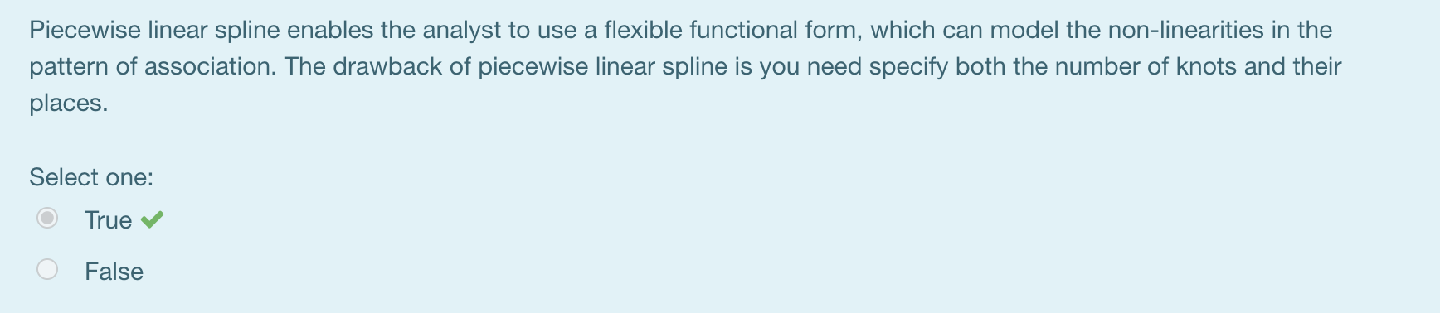

Con: requires decisions from the analyst (like, How many knots? Where to locate them) and often it takes several trials to get satisfying results.

(notes: use “more” and “less” is fine, don’t use increase and decrease)

